**Lab 20-08-2024**

To create our own crypto wallet and blockchain first we need to setup a platform and install dependencies related to it. Please follow the steps below for that purpose.

1. Download and install Oracle VM Virtual Box using the link below:

<https://www.virtualbox.org/wiki/Downloads>

1. Download Desktop image of Ubuntu 18.04.6 LTS (Bionic Beaver) using the link below

<https://releases.ubuntu.com/18.04/>

1. Run Virtual Box and click on new

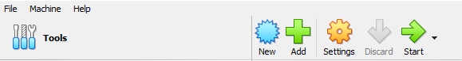

1. Type the name of your choice in the Name field, select the path of ISO image file that you downloaded earlier. Check the box telling you to skip unattended Installation.

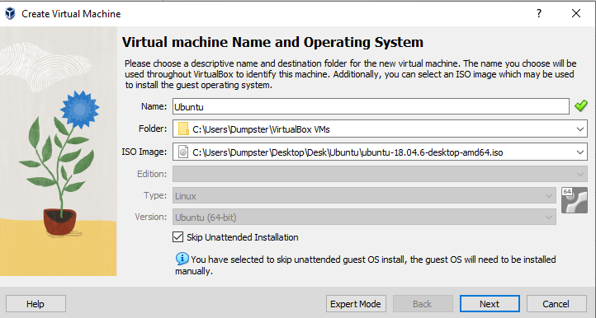

1. Allocate as much Base memory and processors as you can spare.

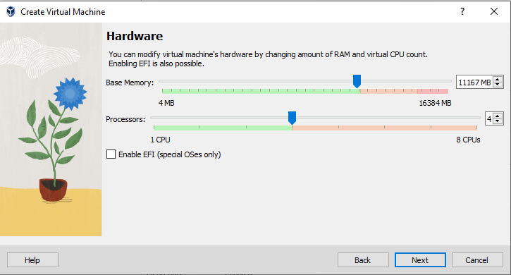

1. Preferably create a virtual hard disk and allocate a suitable size to it (20-25 GB).

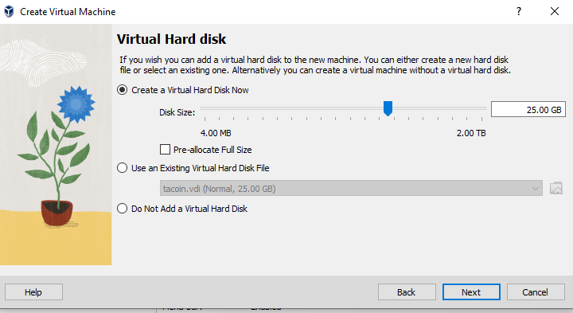

1. Finish the setting up process. Select your Virtual Machine and click on Start.

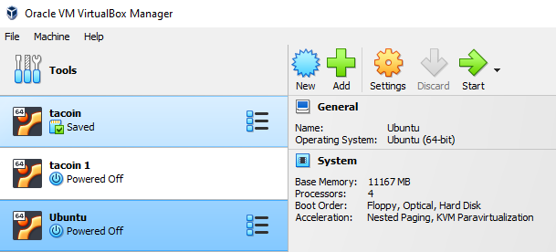

1. For the first time it will take some time, finish the Ubuntu installation process. Choose normal installation, and erase disk option (it will not affect the data on your hard disk) during the process.
2. After installation restart your virtual machine or Virtual Box altogether and ensure that your Ubuntu VM is running. Don’t worry about the window size right now. We’ll come to that later.

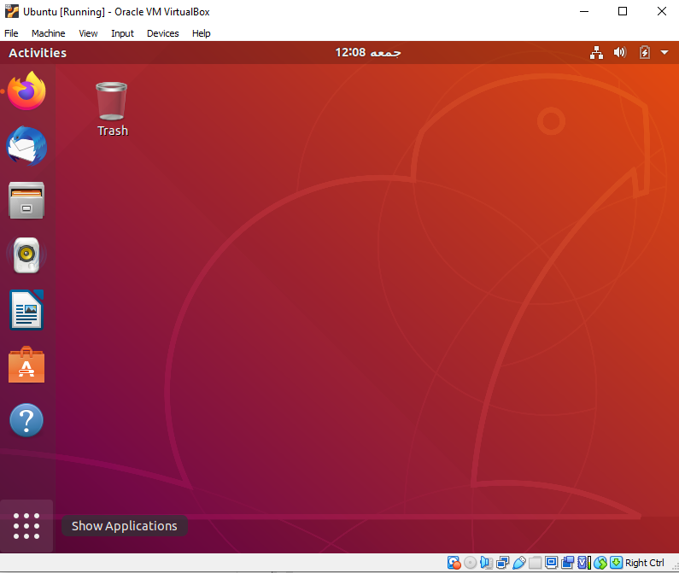

1. Search for terminal and open it. Run the following command

**“sudo apt-get update”**

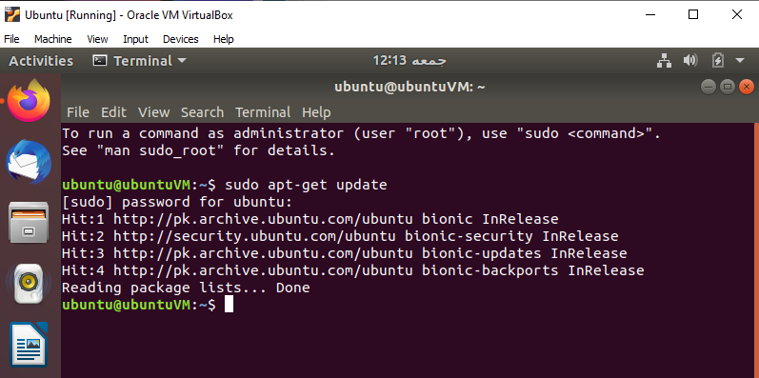

1. Now run this command line

**“sudo apt-get install build-essential gcc make perl dkms”**

Press “Y” to continue.

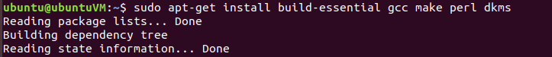

1. Now reboot the Virtual Machine using command **“reboot”**.
2. In the VM devices tab, click on insert guest additions CD image. Click Run on the next prompt. Enter your password.

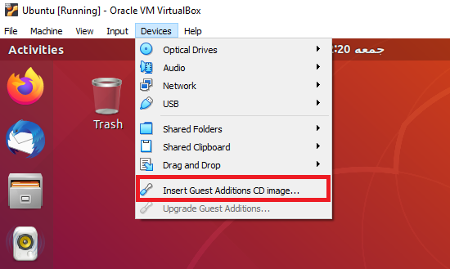

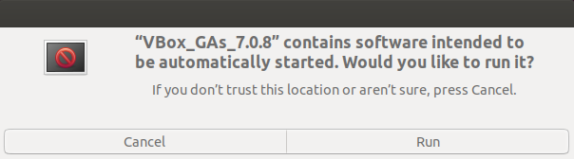

1. Reboot the machine by typing **“reboot”** in your terminal. After the reboot you should be able to change VM resolution/window size as per your convenience.
2. Eject the guest image from your desktop by right clicking it and selecting eject.
3. Open your terminal and install the dependencies required for your wallet by typing and running the commands below in their respective order. During execution if prompted press “Y” to continue the execution.
4. **sudo apt-get install git**
5. **sudo apt-get install build-essential libtool autotools-dev automake pkg-config libssl-dev libevent-dev bsdmainutils**
6. **sudo apt-get install libboost-system-dev libboost-filesystem-dev libboost-chrono-dev libboost-program-options-dev libboost-test-dev libboost-thread-dev**
7. **sudo apt-get install libboost-all-dev**
8. **sudo apt-get install software-properties-common**
9. **sudo add-apt-repository ppa:bitcoin/bitcoin**
10. **sudo apt-get update**
11. **sudo apt-get install libdb4.8-dev libdb4.8++-dev**
12. **sudo apt-get install libminiupnpc-dev**
13. **sudo apt-get install libzmq3-dev**
14. **sudo apt-get install libqt5gui5 libqt5core5a libqt5dbus5 qttools5-dev qttools5-dev-tools libprotobuf-dev protobuf-compiler**
15. **sudo apt-get install libqt4-dev libprotobuf-dev protobuf-compiler**
16. **sudo apt-get install openssl1.0**
17. **sudo apt-get install libssl1.0-dev**
18. Shut down your VM and be sure that you click on “save the machine state” in the Virtual Box exit prompt.